Development of a Secure Web Application Using Agile Methodology with Integrated DevSecOps
Ashraf Uddin
Id: 30329396


Supervised by
Dr Md Ashraf Uddin
OR
Associate Professor John Ayoade
Submitted in [partial] fulfilment of the requirements for the degree of
[e.g. Master of Information Technology (Cybersecurity Major)]

School of Information Technology
Crown Institute of Higher Education
August 2024

Keywords

- Access Control
- Agile Methodology
- Continuous Security Integration
- Data Encryption
- DevSecOps
- Penetration Testing
- Role-Based Access Control
- Secure Coding Practices
- Secure Web Application
- Security Requirements
- Software Development Lifecycle
- Threat Analysis
- Web Application Security.

Abstract
This project explores the development of a secure web application through the application of Agile methodology and the integration of DevSecOps practices. The primary objective of the project was to design and implement a web application that meets stringent security requirements while maintaining the flexibility and responsiveness characteristic of Agile development. The project involved a comprehensive analysis of potential security threats and the specification of both functional and non-functional security requirements, which guided the design and development phases.
To ensure security was embedded at every stage of the software development lifecycle, DevSecOps practices were adopted, enabling continuous security integration through automated testing, secure coding standards, and real-time monitoring. Key security features implemented include role-based access control, data encryption, secure communication protocols, and robust logging and monitoring mechanisms. The application was subjected to rigorous testing, including unit testing, integration testing, and penetration testing, to validate its security and functionality.
Despite certain limitations, such as time constraints and the inherent challenges of integrating new security tools, the project successfully delivered a secure and scalable web application. The findings from this project highlight the effectiveness of combining Agile and DevSecOps in achieving a secure software development process. Future work could involve extending the application’s capabilities with advanced security features and exploring its deployment in a multi-cloud environment.

Table of Contents
Keywords i
Abstract ii
Table of Contents iii
List of Figures v
List of Tables vi
List of Abbreviations vii
Statement of Original Authorship viii
Acknowledgements ix
Chapter 1: Introduction 1
1.1 Background of the study 1
1.2 statement of the problem 1
1.3 Aims 1
1.4 objectives 1
1.5 The Approach Adopted 2
1.6 Project Management and plan 2
Chapter 2: Project Management Plan 3
2.1 2. Project Management Steps 3
Chapter 3: Literature Review 7
3.1 Background context 7
3.2 importance of security in software development 7
3.3 Common threats and vulnerabilities in software development 8
3.4 secure software development Methodologies 8
3.5 Chosen Methodology for Secure Development 12
3.6 Summary 12
Chapter 4: Secure Software Specification and Design 13
4.1 Introduction 13
4.2 Secure System Design 14
4.3 Summary 20
Chapter 5: Secure Development and Implementation 21
5.1 Introduction 21
5.2 Secure System Implementation 21
5.3 Summary 25
Chapter 6: Secure Testing and Results 27
6.1 Introduction 27
6.2 Secure Test Planning 27
6.3 Summary 30
Chapter 7: Critical Evaluation and Security Audit 32
7.1 Introduction 32
7.2 Security Evaluation Methodology 32
7.3 Achievements and Security Outcomes 33
7.4 Product Evaluation and Future Enhancements 33
7.5 Lessons Learned 34
7.6 Summary 36
Chapter 8: Conclusions 37
8.1 Limitations 37
8.2 Future Works 37
8.3 Conclusion 38
Bibliography 39
Appendices 41
Appendix A Title 41

List of Figures

Figure 1: Waterfall model 6
Figure 2: DevSecOps 8
Figure 3: Secure system design 11
Figure 4: Use case diagram 12
Figure 5: Activity diagram 13
Figure 6: Sequence diagram 14
Figure 7: Class diagram 15
Figure 8: Wireframes diagram 16

List of Tables
Table 1: Project charter template 3
Table 2: Project Planning 4

List of Abbreviations
If appropriate, list any abbreviations used in the thesis.

Statement of Original Authorship
The work contained in this thesis has not been previously submitted to meet requirements for an award at this or any other higher education institution. To the best of my knowledge and belief, the thesis contains no material previously published or written by another person except where due reference is made.

Signature: _________________________

Date: _________________________

Acknowledgements

Introduction
In the Introduction chapter, students should focus on setting the stage for the rest of the document by clearly defining the purpose, scope, and significance of their work. Here’s a guide on how they should structure the Introduction chapter:

Background of the study
Purpose: Provide a brief overview of the broader context in which the project is situated. This could involve discussing the industry, technology, or problem area that the project addresses.
Content: Explain why the topic is important, mentioning any key trends or challenges. This section should help the reader understand the motivation behind the project.

statement of the problem
Purpose: Clearly articulate the specific problem or gap that the project aims to address.
Content: Describe the problem in detail, explaining its implications and why it needs to be solved. If applicable, provide examples or evidence to highlight the urgency or significance of the problem.

Aims
Purpose: State the overall aim or goal of the project.
Content: Clearly define what the project seeks to achieve. This should be a broad statement that encapsulates the primary objective of the work.

objectives
Purpose: Break down the aim into specific, measurable objectives.
Content: List the objectives in a logical sequence. Each objective should be a clear step towards achieving the overall aim. Objectives should be SMART (Specific, Measurable, Achievable, Relevant, and Time-bound).

The Approach Adopted
Purpose: Provide an overview of the methodology or approach used to achieve the project’s objectives.
Content: Briefly describe the methods, tools, or frameworks that will be used. This section should give the reader a sense of how the research or development will be carried out.

Project Management and plan
Purpose: Outline the plan for completing the project, including timelines and milestones.
Content: Describe the project management approach, such as the use of agile or waterfall methodologies. Include a summary of key milestones and deliverables, and how progress will be tracked.

Project Management Plan

Project Management Steps
You can break down the Project Management Plan into the following sub-sections, each detailing a specific aspect of project management:

Project Initiation
Purpose: Define the goals, scope, and objectives of the project.
Content: Include a project charter, stakeholder analysis, and initial risk assessment. This step should clearly outline what the project aims to achieve, and the key stakeholders involved. You can use the following project charter template.
Table 1: Project charter template
Project Charter

Project Name
Project Description
Project Manager |  | Date Approved
Project Sponsor |  | Signature
Business Case |  | Expected Goals/Deliverable
Team Members
Name | Role
Risks and Constraints |  | Milestones

Project Planning
Purpose: Develop a detailed plan for how the project will be executed.
Content: This includes creating a Work Breakdown Structure (WBS), defining project milestones, setting timelines, and allocating resources. It should also cover the creation of a project schedule using tools like Gantt charts.
Table 2: Project Planning
Task or Subtask | Resources | Start and End Dates | Estimated Effort in Hours | Estimated Capital Expense | Estimated Noncapital Expense | Dependencies
Task 1 | Resource | S:  E: | 0 | 0 | 0 | 0
Task 2 | Resource | S:  E: | 0 | 0 | 0 | 0
Task 3 | Resource | S:  E: | 0 | 0 | 0 | 0
Task 4 | Resource | S:  E: | 0 | 0 | 0 | 0

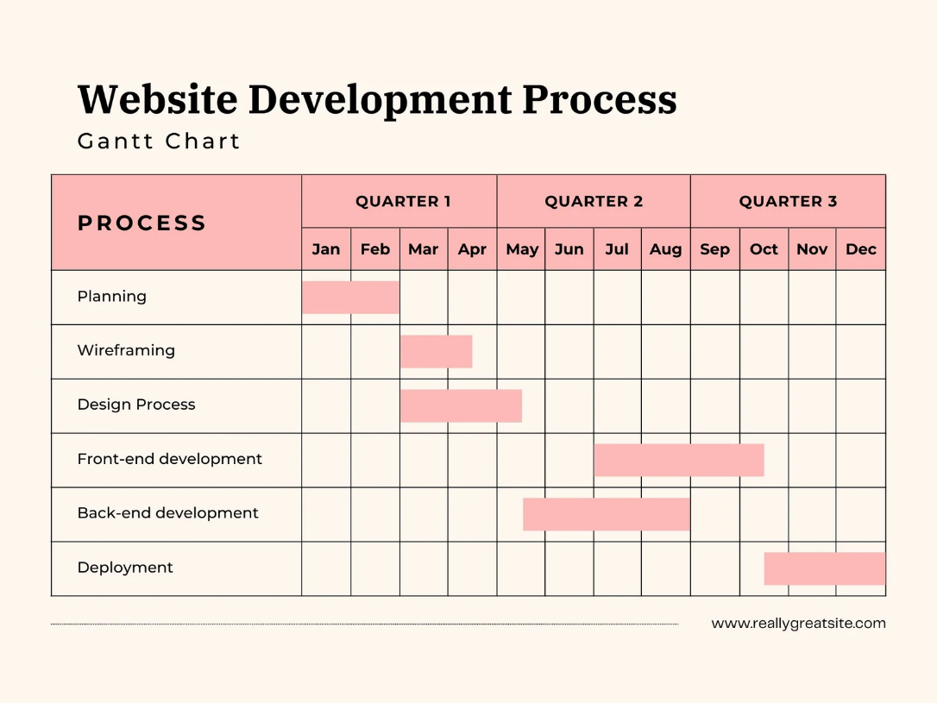
Figure 1: Gantt chart

Project Execution
Purpose: Carry out the project plan to deliver the project’s objectives.
Content: Describe the process of executing the project, including the coordination of people and resources. It should cover task assignments, team management, and how progress will be tracked.
- Task Assignment: Detail how tasks are assigned to team members.
- Team Management: Discuss team roles, responsibilities, and leadership.
- Status Reporting: Explain how project progress will be reported and documented.

Project Monitoring and Control
Purpose: Track, review, and regulate project progress and performance.
Content: Include methods for monitoring project activities, tracking performance, and managing changes to the project plan.
- Performance Metrics: Define the key performance indicators (KPIs) for the project.
- Change Management: Outline the process for managing changes to the project scope, schedule, or resources.
- Risk Monitoring: Describe how risks will be monitored throughout the project.

Project Closure
Purpose: Formally close the project and hand over deliverables.
Content: This includes finalizing all project activities, closing contracts, and obtaining formal acceptance of the project deliverables. It should also include a post-project evaluation, or lessons learned.
- Project Handover: Describe the process of handing over the project deliverables to the client or stakeholders.
- Final Documentation: Ensure all project documentation is completed and archived.
- Lessons Learned: Document what went well, what didn’t, and how future projects can benefit from these insights.
- Project Review and Approval: Outline the process for reviewing and getting formal approval for project completion.

To ensure project management is integrated with the rest of the project, reference the Project Management Plan in other relevant sections, such as during the design, implementation, and testing phases. For example:
In the Introduction: Briefly mention that the project will be managed according to the Project Management Plan, which is detailed in Section 2.
In each major phase: Include a short subsection on how project management principles will be applied in that phase, such as tracking progress or managing changes.

Literature Review
In the literature review section, you should provide a comprehensive analysis of existing research, theories, and practices relevant to your project topic. This section serves to contextualize your work within the broader field, identify gaps in current knowledge, and demonstrate how your project builds on or diverges from existing studies.
The literature on secure software development has evolved significantly over the past two decades, with a strong emphasis on integrating security into every phase of the software development lifecycle (SDLC). Early studies, such as those by McGraw (2004), highlighted the importance of secure coding practices and the role of security testing in identifying vulnerabilities before deployment. More recent research has expanded this view, advocating for the adoption of holistic frameworks like DevSecOps, which integrate security into the continuous integration and continuous delivery (CI/CD) pipeline, as noted by Schneider and colleagues (2018). Despite these advancements, gaps remain in understanding the practical challenges of implementing these methodologies in dynamic, Agile environments. This review critically examines key contributions to the field, including studies on secure software design principles, threat modeling techniques, and the effectiveness of various security testing tools, providing a foundation for the approach adopted in this project.

Background context
In the rapidly evolving field of software development, ensuring the security of applications and systems has become paramount. As organizations increasingly rely on software to handle sensitive data, conduct business operations, and provide services to users, the risks associated with insecure software have grown exponentially. Cyberattacks targeting vulnerabilities in software can lead to data breaches, financial losses, reputational damage, and legal repercussions. Therefore, understanding the context within which secure software development takes place is crucial for developing robust and resilient applications.
The shift towards digital transformation has necessitated the integration of security at every stage of the software development lifecycle. This evolution has been driven by the growing complexity of software systems, the increasing sophistication of cyber threats, and the heightened regulatory demands for data protection and privacy. In this context, secure software development is not merely an option but a necessity to safeguard the integrity, confidentiality, and availability of information systems.

importance of security in software development
Security is a critical component of software development, influencing not only the safety of the final product but also its long-term viability and trustworthiness. The importance of security in software development cannot be overstated, as insecure software can lead to significant vulnerabilities that are often exploited by malicious actors. These vulnerabilities can result in unauthorized access, data breaches, and service disruptions, undermining the software's intended functionality and user trust.
The integration of security measures throughout the software development lifecycle ensures that potential threats are identified and mitigated early on. This proactive approach helps in minimizing the risk of security incidents that can have far-reaching consequences, including financial losses, legal penalties, and damage to the organization's reputation. Moreover, as regulatory bodies increasingly mandate strict compliance with security standards, incorporating security into software development has become essential for meeting legal and industry requirements.
In a world where cyber threats are constantly evolving, secure software development practices enable organizations to stay ahead of potential attackers. By embedding security into the fabric of software development, developers can create resilient applications that not only meet functional requirements but also protect against a wide array of security threats.

Common threats and vulnerabilities in software development
The landscape of software development is fraught with numerous threats and vulnerabilities that can compromise the security of an application. Common threats include malware, ransomware, phishing, and distributed denial-of-service (DDoS) attacks, each capable of causing significant damage to an organization’s assets and data. These threats exploit vulnerabilities in the software, which may arise from flaws in design, coding errors, or inadequate security measures during development.
Some of the most prevalent vulnerabilities in software development include injection attacks (such as SQL injection), cross-site scripting (XSS), and buffer overflows. These vulnerabilities often result from inadequate input validation, poor coding practices, or the failure to follow secure coding standards. Additionally, the increased reliance on third-party libraries and frameworks has introduced new risks, as these components may harbor hidden vulnerabilities that can be exploited if not properly vetted and managed.
Understanding these threats and vulnerabilities is crucial for developers to implement effective security controls. By identifying the most common attack vectors and weak points in software, developers can take proactive steps to fortify their code against potential exploitation.

secure software development Methodologies
The development of secure software necessitates the adoption of methodologies that integrate security practices throughout the software development lifecycle. Secure Software Development Methodologies (SSDMs) are frameworks that guide developers in incorporating security considerations at every stage of the development process, from planning and design to coding, testing, and maintenance. These methodologies are designed to produce software that is not only functional and efficient but also resilient against cyber threats.
Several methodologies have been developed to address the specific challenges of secure software development, including the Waterfall methodology, Agile methodology, and DevSecOps. Each of these approaches offers unique advantages and challenges when applied to security, and selecting the appropriate methodology depends on the specific needs and context of the project.

Waterfall Methodology and Security Implications
The Waterfall methodology is a linear and sequential approach to software development, where each phase must be completed before the next begins. This traditional model has been widely used for decades and is particularly effective in projects with well-defined requirements and minimal changes. However, when it comes to security, the Waterfall methodology presents both strengths and weaknesses.

Waterfall Strengths and Security Considerations
One of the primary strengths of the Waterfall methodology in the context of security is its structured approach. Since each phase of the development process is clearly defined, security requirements can be systematically incorporated from the initial design phase. This allows for thorough documentation and the implementation of security controls at each stage. Furthermore, the rigorous testing phase in Waterfall ensures that security vulnerabilities are identified and addressed before the software is deployed.

Waterfall Weaknesses and Security Risks
Despite its strengths, the Waterfall methodology also has significant drawbacks in terms of security. Its rigid structure can lead to challenges if security vulnerabilities are discovered late in the development process, as revisiting earlier phases to address these issues can be costly and time-consuming. Additionally, the lack of flexibility in Waterfall means that it is less adaptive to emerging security threats that may arise during the development process. This can result in software that is secure at the time of planning but potentially vulnerable by the time it is completed.
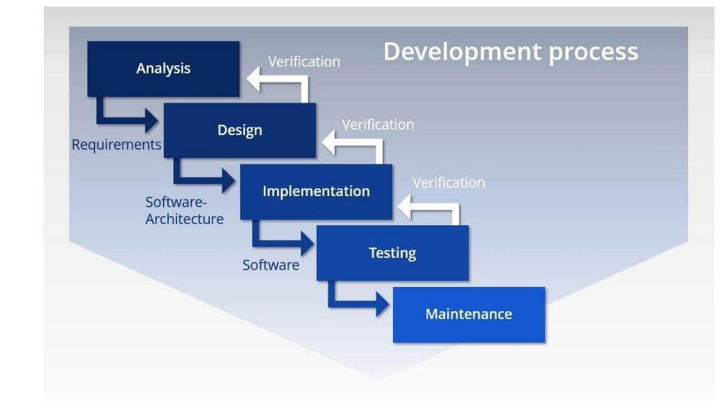
Figure 2: Waterfall model

Agile Methodology and Secure Development
The Agile methodology is characterized by its iterative and incremental approach, which emphasizes flexibility, collaboration, and customer feedback. Unlike the Waterfall methodology, Agile allows for continuous integration of changes throughout the development process, making it well-suited for projects where requirements evolve over time. In terms of security, Agile offers several strengths but also presents unique challenges.

Strengths of Agile in Security Context
Agile's iterative nature allows for continuous security assessments and the ability to respond quickly to new threats. Security can be integrated into each iteration, ensuring that vulnerabilities are identified and mitigated early and often. This approach fosters a culture of shared responsibility for security, where all team members, including developers, testers, and security experts, collaborate to build secure software. Additionally, the regular feedback loops in Agile enable ongoing refinement of security measures based on user and stakeholder input.

Weaknesses of Agile in Security Context
However, the fast-paced environment of Agile can sometimes lead to security being overlooked in favor of speed and functionality. The focus on rapid development cycles may result in insufficient time being allocated to comprehensive security testing and risk assessment. Moreover, the decentralized nature of Agile teams can make it challenging to enforce consistent security practices across all iterations. Without a strong emphasis on security, there is a risk that vulnerabilities may slip through the cracks during the development process.

DevSecOps Integration
DevSecOps is an evolution of the DevOps model, which emphasizes the integration of security practices into the continuous delivery pipeline. By embedding security into the DevOps workflow, DevSecOps aims to ensure that security is considered at every stage of the development process, from initial coding to deployment and beyond.

Benefits of DevSecOps
The primary benefit of DevSecOps is its ability to deliver secure software at speed. By automating security checks and integrating them into the continuous integration/continuous deployment (CI/CD) pipeline, DevSecOps enables teams to detect and address security vulnerabilities in real-time. This approach not only reduces the time to market but also ensures that security is a core component of the development process rather than an afterthought. Additionally, DevSecOps fosters a collaborative culture where developers, operations, and security teams work together to build secure software.

Challenges in Implementing DevSecOps
Implementing DevSecOps, however, comes with its own set of challenges. One of the main difficulties is the need for cultural change within organizations, where security is often seen as a separate discipline rather than an integral part of the development process. Teams must overcome silos and learn to collaborate effectively, which can be a significant shift in mindset. Additionally, the automation of security processes requires investment in tools and training, which can be a barrier for some organizations. Ensuring that these tools are properly configured and that teams are adequately trained is crucial for the successful adoption of DevSecOps.
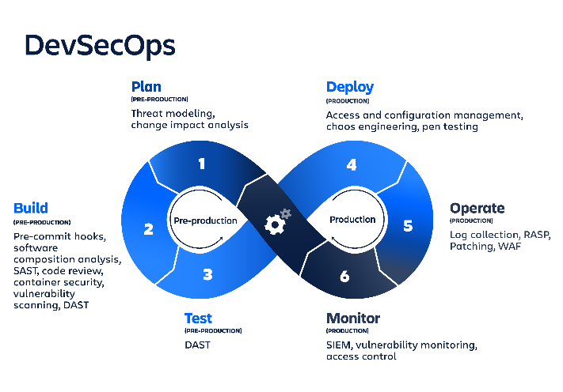
Figure 3: DevSecOps

Chosen Methodology for Secure Development
After evaluating the strengths and weaknesses of various secure software development methodologies, the chosen approach for this project is [insert chosen methodology here, e.g., DevSecOps]. This methodology was selected because it aligns with the project's requirements for continuous security integration, flexibility in development, and the ability to respond rapidly to emerging threats. By adopting [chosen methodology], the project aims to achieve a balance between delivering functional software efficiently and maintaining a high standard of security throughout the development lifecycle.
The choice of this methodology is also driven by the project's specific context, including the need to meet regulatory compliance, protect sensitive data, and ensure that the final product is resilient against the latest cyber threats. The implementation of [chosen methodology] will involve a combination of automated security tools, continuous monitoring, and collaborative practices that engage all stakeholders in the secure development process.

Existing Works/Projects/Applications
- Contextualize Your Research: Discussing existing works helps to place your project within the broader context of the field. It shows that you are aware of what has already been done and helps to justify the need for your project.
- Identify Gaps: By reviewing existing projects or applications, you can identify gaps in the current state of the art, which your work aims to address. This is crucial for establishing the originality and relevance of your research.
- Compare and Contrast: Analyzing existing works allows you to compare and contrast different approaches, methodologies, and outcomes. This can help you position your project and explain why you chose a particular method or approach.
- Demonstrate Knowledge: Discussing related projects or applications demonstrates your familiarity with the field and enhances the credibility of your work.

Summary

Secure Software Specification and Design
Secure Software Specification and Design is a critical section of your project where you detail the blueprint for building a secure software system. This chapter should comprehensively cover the processes, methodologies, and design decisions that ensure the software is secure from the ground up. Chapter 4 will provide a comprehensive blueprint that guides the secure development of your software. This chapter serves as a critical bridge between identifying security needs and actually implementing a secure system, ensuring that all security aspects are thoroughly considered and integrated into the software design.

Introduction
The design phase of a software development project is critical to ensuring that the final product not only meets functional requirements but also incorporates robust security measures. This chapter focuses on the security aspects of software design, detailing how security requirements are analyzed, specified, and integrated into the overall system design. By establishing a secure architecture and implementing security considerations across various design models, the goal is to create a system that is resilient to threats and vulnerabilities while delivering the intended functionality.

Security requirements analysis
Security Requirements Analysis involves the systematic identification and evaluation of security needs within a software system. This process begins with understanding the potential threats and vulnerabilities that the system may face, followed by determining the specific security controls and measures required to mitigate these risks. The analysis is informed by a range of factors, including the sensitivity of the data being processed, the regulatory environment, and the potential impact of security breaches.
During this phase, input is gathered from stakeholders, including developers, security experts, and end-users, to ensure that all relevant security concerns are addressed. The outcome of the Security Requirements Analysis is a comprehensive list of security needs that will guide the subsequent phases of system design and implementation.

security requirement specification
The Security Requirement Specification translates the findings from the Security Requirements Analysis into detailed, actionable specifications that guide the development process. This document outlines the specific security controls, mechanisms, and protocols that must be implemented to protect the system against identified threats.

These specifications are categorized into functional and non-functional security requirements, providing a clear and structured approach to ensuring that security is integrated into all aspects of the system. By specifying security requirements early in the design process, developers can make informed decisions that align with the overall security objectives of the project.

Functional Security Requirements
Functional Security Requirements define the specific security-related functions that the system must perform. These requirements ensure that the system has the necessary capabilities to prevent unauthorized access, detect and respond to security incidents, and protect data integrity and confidentiality.
Examples of functional security requirements include user authentication mechanisms, access control policies, encryption of sensitive data, and logging of security events. Each functional requirement is designed to address a particular threat or vulnerability identified during the Security Requirements Analysis.

Non-Functional Security Requirements
Non-Functional Security Requirements focus on the quality attributes of the system related to security, such as performance, usability, and reliability under security constraints. These requirements ensure that security measures do not negatively impact the system's overall performance or user experience.
Examples of non-functional security requirements include system availability during attacks, the system's ability to scale securely under increased load, and the ease with which security updates can be applied. Non-functional requirements are critical for maintaining a balance between security and other system attributes, ensuring that the system remains both secure and efficient.

Secure System Design
Secure System Design involves creating a blueprint for the software system that incorporates the specified security requirements into its architecture and components. This phase translates the security requirements into tangible design elements, ensuring that security is integrated into every layer of the system, from data storage to user interfaces.

The design process includes creating detailed diagrams and models that represent the system's architecture, data flow, and interactions, all with a focus on maintaining security. By embedding security into the design, developers can minimize the risk of vulnerabilities and ensure that the system is robust against potential threats.
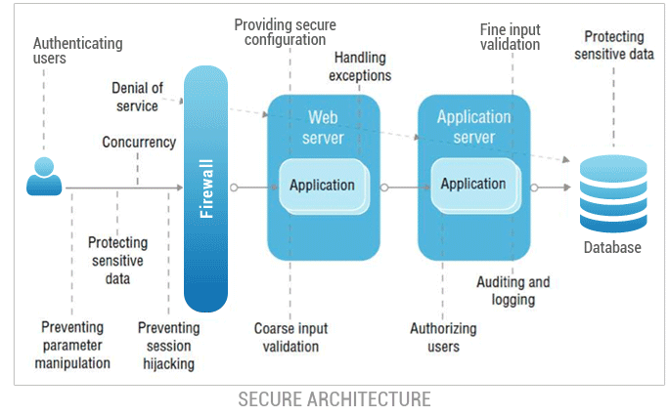
Figure 4: Secure system design

Secure System Architecture
The Secure System Architecture is the foundational blueprint of the software system, outlining the structure and interaction of its various components with a focus on security. This architecture defines how the system's security controls are implemented across different layers, such as the network, application, and data layers.
Key elements of a secure system architecture include the use of firewalls, encryption protocols, secure communication channels, and access control mechanisms. The architecture is designed to ensure that security is enforced consistently throughout the system, protecting against both external and internal threats.

Security Considerations in Entity Relationship Diagram
The Entity Relationship Diagram (ERD) is a critical tool in database design, representing the relationships between different data entities. Security considerations in the ERD involve ensuring that sensitive data is properly protected through encryption, access controls, and secure data storage practices.
Incorporating security into the ERD includes defining which entities contain sensitive information, how that information is accessed and shared, and the application of data integrity constraints. By addressing security in the ERD, developers can ensure that the database design supports secure data management and prevents unauthorized access or data breaches.

Secure Use Case Diagram
The Use Case Diagram illustrates the interactions between users (actors) and the system, focusing on the functionality provided by the system. A Secure Use Case Diagram extends this by including security-specific interactions, such as authentication, authorization, and security incident response.

Security considerations in the Use Case Diagram ensure that every interaction between users and the system is protected against potential threats. For example, a use case for user login would include security measures like multi-factor authentication and logging of failed login attempts. This ensures that the system's functionality is delivered securely.
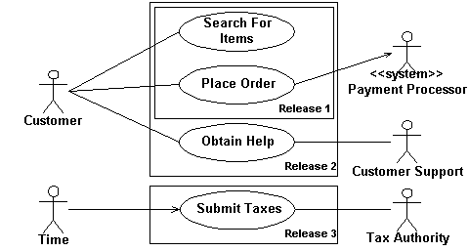
Figure 5: Use case diagram

Secure Activity/Sequence Diagram
The Activity Diagram represents the workflow of a system, showing the sequence of activities and decisions. In a Secure Activity Diagram, security controls are integrated into the workflow to ensure that each step is performed securely.
For example, an activity diagram for processing a financial transaction would include steps for validating user identity, encrypting transaction data, and logging the transaction for audit purposes. By embedding security into the activity flow, the diagram ensures that every operation is carried out with security in mind.
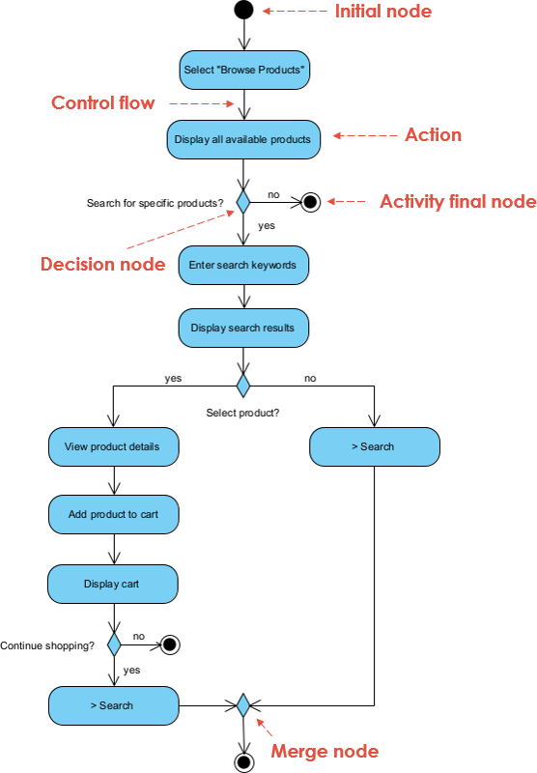
Figure 6: Activity diagram

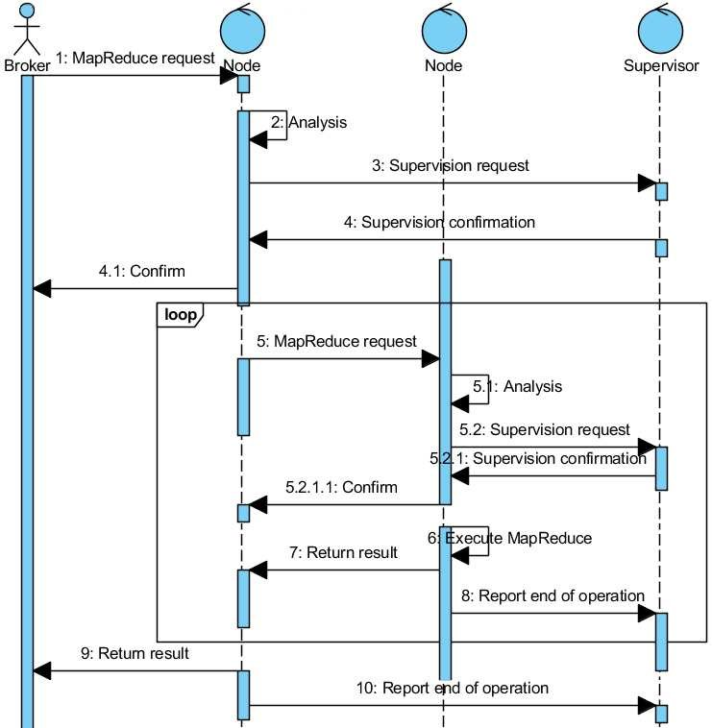
Figure 7: Sequence diagram

Secure Class Diagram
The Class Diagram is a key element of object-oriented design, depicting the system's classes, their attributes, methods, and relationships. In a Secure Class Diagram, security considerations are incorporated into the design of each class, ensuring that security principles like least privilege and encapsulation are followed.
For example, access controls can be designed into classes to ensure that only authorized users can invoke certain methods or access sensitive attributes. This approach ensures that the software's object-oriented structure supports secure coding practices and reduces the risk of security vulnerabilities.
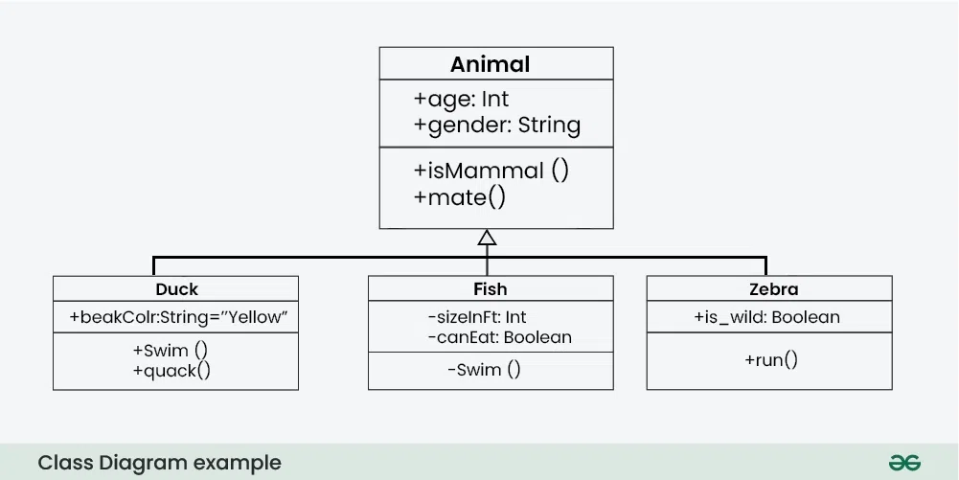
Figure 8: Class diagram

Secure Deployment Diagram
The Deployment Diagram shows how the software system will be deployed across hardware nodes, including servers, networks, and other infrastructure. A Secure Deployment Diagram includes security measures like firewalls, intrusion detection systems, and secure communication protocols.
This diagram ensures that the deployment architecture is resilient against attacks, with critical components isolated in secure environments and communication channels protected by encryption. By planning the deployment with security in mind, developers can prevent common deployment-related vulnerabilities.

Secure Wireframe Design
Wireframe Design represents the layout of the user interface (UI) elements and the overall user experience. In a Secure Wireframe Design, security considerations are integrated into the UI to ensure that users are guided to interact with the system securely.
For example, the wireframe design might include clear prompts for password creation, warnings for insecure actions, and intuitive placement of security features like logout buttons. The goal is to make security an integral part of the user experience, helping users maintain secure interactions with the system.
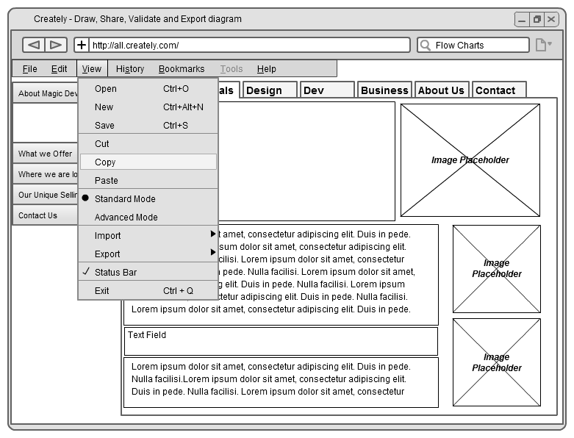
Figure 9: Wireframes diagram

Summary
This chapter has outlined the approach to secure system design, starting with the analysis and specification of security requirements and progressing through the design of a secure system architecture and various design diagrams. Each section focused on how security considerations are integrated into the design process, ensuring that the final system will be resilient against threats and vulnerabilities. The detailed design models, including the secure system architecture, entity relationship diagram, use case diagram, activity diagram, class diagram, deployment diagram, and wireframe design, provide a comprehensive blueprint for developing a secure software system. The next chapter will focus on the implementation of these design elements and the practical steps taken to bring the secure design to life.

Secure Development and Implementation

Introduction
The implementation phase is where the design specifications are transformed into a functional and secure software system. In this chapter, the focus will be on the practical aspects of implementing the secure system design, as outlined in the previous chapter. The implementation involves setting up a secure development environment, using appropriate tools and frameworks, adhering to secure coding practices, and addressing challenges encountered during the process. The chapter also discusses the integration of cloud security measures, the implementation of security features, and the solutions adopted to overcome any security issues that arose during development.

Secure System Implementation
Secure system implementation is the process of turning design specifications into a working system that meets both functional and security requirements. This involves configuring the development environment, selecting secure development tools, and applying secure coding practices throughout the software development lifecycle. The implementation also includes deploying the system on secure platforms and ensuring that security features are effectively integrated into the system to protect against potential threats.

Development Environment
The development environment plays a crucial role in ensuring the security of the software being developed. This environment includes the hardware, software, and network configurations used by developers during the coding and testing phases. For this project, a secure development environment was established to prevent unauthorized access, mitigate the risk of data leaks, and ensure that all code and assets are protected during development.
Key measures implemented in the development environment include the use of encrypted connections (e.g., VPNs), access controls to restrict developer access to sensitive components, and secure version control systems to track changes and prevent unauthorized code alterations. The environment is also isolated from the production environment to minimize the risk of accidental exposure of sensitive data or vulnerabilities.

Secure Development Tools
Secure development tools are essential for identifying, mitigating, and preventing security vulnerabilities throughout the coding process. For this project, a suite of secure development tools was selected based on their ability to integrate seamlessly with the chosen development environment and frameworks.
These tools include static and dynamic code analysis tools to identify potential security flaws, secure code editors that highlight insecure coding patterns, and automated testing tools designed to simulate various security threats. Additionally, tools for managing cryptographic keys, performing secure builds, and conducting security audits were also employed to ensure that the software meets all security requirements.

Secure Coding Practices
Secure coding practices are critical to minimizing the risk of introducing vulnerabilities during the software development process. These practices involve following established guidelines and best practices that prevent common security issues such as buffer overflows, SQL injection, and cross-site scripting (XSS).
Throughout the development process, secure coding practices were enforced by adhering to standards such as OWASP Top Ten, conducting regular code reviews with a focus on security, and implementing input validation, output encoding, and proper error handling. By embedding security into the coding phase, the project aimed to reduce the attack surface and ensure that the final product is resilient to potential threats.

Secure Development Frameworks
Secure development frameworks provide the foundation for building secure applications by offering built-in security features and guidelines for developers. For this project, the chosen secure development framework was [insert framework name here], selected for its robust security architecture and support for secure coding practices.

This framework offers features such as role-based access control, data encryption, and secure session management, which were leveraged to implement the system's security requirements. Additionally, the framework's community and documentation provided valuable resources for staying up to date with the latest security patches and best practices.

Secure Development Platforms
The choice of development platform can have a significant impact on the security of the software system. For this project, the development platform was selected based on its security features, scalability, and compatibility with the chosen development tools and frameworks.
The platform supports secure deployment practices, such as containerization, to isolate different components of the application and reduce the risk of cross-contamination in the event of a security breach. The platform also integrates with security monitoring tools to provide real-time visibility into the system's security posture during development and testing.

Cloud Security: Server and Database
With the increasing reliance on cloud services, ensuring the security of cloud-based servers and databases is paramount. For this project, cloud security measures were implemented to protect the server and database environments where the application is hosted.
These measures include the use of encryption for data at rest and in transit, multi-factor authentication (MFA) for accessing cloud resources, and regular security audits to identify and remediate potential vulnerabilities. Additionally, the cloud provider's security services, such as identity and access management (IAM), were leveraged to enforce strict access controls and monitor for suspicious activities.

Security Features Implementation
The implementation of security features is a critical component of the secure system development process. These features are designed to protect the system from a wide range of threats, including unauthorized access, data breaches, and malware.

Key security features implemented in this project include user authentication and authorization mechanisms, encryption of sensitive data, secure communication protocols (e.g., HTTPS), and logging and monitoring of security events. Each of these features was rigorously tested to ensure that they function as intended and provide the necessary level of protection against potential security threats.

System Implementation Challenges
Implementing a secure software system is fraught with challenges, many of which can impact the overall success of the project. Some of the key challenges encountered during this project include the integration of new security tools into the existing development pipeline, balancing the need for security with performance and usability, and ensuring that all team members adhered to secure coding practices.
Additionally, the evolving nature of security threats posed a challenge, requiring the team to stay vigilant and responsive to emerging risks. Addressing these challenges required careful planning, ongoing communication among team members, and a commitment to maintaining a strong security posture throughout the implementation process.

Security Issues Encountered
During the implementation phase, several security issues were encountered that required immediate attention. These issues included vulnerabilities discovered during code reviews, misconfigurations in the development environment, and difficulties in implementing certain security features due to compatibility issues with existing infrastructure.
One specific issue involved a potential SQL injection vulnerability in one of the application's modules, which was identified through automated testing. This vulnerability was addressed by revisiting the affected code, implementing parameterized queries, and conducting additional testing to ensure that the fix was effective.

Solutions Adopted
To address the security issues encountered during implementation, a range of solutions were adopted. These solutions included revising and reinforcing secure coding practices, integrating additional security tools for automated testing and monitoring, and conducting comprehensive security training sessions for the development team.
In the case of the SQL injection vulnerability, the solution involved implementing secure coding techniques, such as input validation and prepared statements, to eliminate the risk of injection attacks. Other solutions included reconfiguring the development environment to enhance security, updating the secure development framework to the latest version, and applying security patches as needed.

Summary

This chapter has provided an overview of the secure system implementation process, highlighting the development environment, tools, coding practices, and frameworks used to create a secure software system. The implementation also addressed the integration of cloud security measures, the deployment of security features, and the challenges encountered during the process. By adopting a systematic approach to security, the project aimed to deliver a robust and resilient software system that meets all security requirements. The next chapter will focus on the testing and evaluation of the implemented system to ensure that it performs securely under real-world conditions.
[Extra page inserted to ensure correct even-page footer for this section. Delete this when chapter is at least 2 pages long.]

Secure Testing and Results

Introduction
The testing phase is a critical step in the software development lifecycle, particularly when it comes to ensuring the security of the system. This chapter focuses on the secure testing strategies employed to validate that the system meets all security requirements and is resilient against potential threats. Through a combination of unit testing, integration testing, functional testing, and specialized security testing techniques such as penetration testing and regression testing, the goal is to identify and address any vulnerabilities that could compromise the system’s integrity, confidentiality, and availability.

Secure Test Planning
Secure Test Planning is the process of defining the objectives, strategies, and resources required to validate the security of the software system. This involves determining the scope of testing, identifying key security requirements to be tested, and selecting appropriate testing methods and tools. The test plan also outlines the schedule, roles, and responsibilities of the testing team, ensuring that all aspects of the system's security are thoroughly evaluated.
The planning phase is crucial as it sets the foundation for systematic and comprehensive security testing, ensuring that all potential vulnerabilities are identified and mitigated before the system is deployed.

Unit Testing for Security
Unit testing for security involves testing individual components or modules of the software to ensure that they function correctly and securely. Each unit is tested in isolation, focusing on security-related aspects such as input validation, error handling, and adherence to secure coding standards.

For example, a unit test might check that a user input function properly sanitizes inputs to prevent SQL injection attacks. By identifying and fixing security issues at the unit level, developers can prevent vulnerabilities from propagating throughout the system.

Secure Integration Testing
Secure Integration Testing focuses on verifying the security of interactions between integrated components of the system. While unit testing ensures that individual modules are secure, integration testing checks that the modules work together securely without introducing new vulnerabilities.
This phase involves testing interfaces, data flow, and communication between components, ensuring that security controls such as encryption, authentication, and authorization are correctly implemented and enforced across the system. Integration testing also includes testing third-party components to ensure that they do not introduce security risks.

Functional and System Security Testing
Functional and System Security Testing evaluates the system’s overall functionality from a security perspective, ensuring that all security features operate as intended. This testing phase verifies that the system complies with the specified security requirements, such as user authentication, access control, and data encryption.
The tests are conducted in an environment that simulates real-world usage, ensuring that the system performs securely under typical operating conditions. This phase also involves stress testing to assess how the system handles high loads and whether it maintains security under pressure.

Security Acceptance Testing
Security Acceptance Testing is the final testing phase before the system is deployed. It involves validating that the system meets all security requirements and is ready for production use. This phase typically includes testing the system’s compliance with organizational security policies, regulatory standards, and industry best practices.
Security acceptance testing is performed by a team of security experts who assess whether the system is secure enough to be released. The testing results are documented, and any identified issues must be resolved before the system can be accepted and deployed.

Regression Testing for Security
Regression Testing for Security is conducted after changes or updates have been made to the system to ensure that previously fixed security vulnerabilities have not been reintroduced. This testing phase is essential whenever new features are added, or existing code is modified, as these changes can inadvertently create new security issues or reintroduce old ones.
The regression testing process involves re-running previously conducted security tests on the modified system and verifying that the system still meets all security requirements. This ensures that the system remains secure after any updates or enhancements.

Penetration Testing
Penetration Testing, also known as ethical hacking, is a proactive security testing method where testers simulate real-world cyberattacks on the system to identify and exploit vulnerabilities. The goal of penetration testing is to assess the system's defenses and uncover security weaknesses that could be exploited by malicious actors.
Penetration testing involves a variety of techniques, including network scanning, vulnerability scanning, social engineering, and exploitation of identified vulnerabilities. The results of the penetration test provide valuable insights into the system’s security posture and highlight areas that require additional security measures.

Test Procedure
The Test Procedure outlines the specific steps and processes followed during the testing phase. It includes detailed instructions on how each test is to be conducted, the tools and methods used, and the criteria for evaluating the results.
The procedure ensures consistency and repeatability in testing, allowing the testing team to systematically evaluate the system's security. It also provides a framework for documenting the testing process and outcomes, ensuring that all tests are thoroughly conducted and properly recorded.

Security Test Suite
The Security Test Suite is a collection of automated and manual tests designed to evaluate the security of the system comprehensively. The suite includes tests for common security vulnerabilities such as SQL injection, cross-site scripting (XSS), and buffer overflows, as well as tests for specific security requirements like encryption and access control.
Each test in the suite is designed to target a particular aspect of the system’s security, providing a comprehensive assessment of its resilience against potential threats. The test suite is regularly updated to include new tests as the system evolves and new security threats emerge.

Test Report
The Test Report documents the results of the security testing process, providing a detailed account of the tests conducted, the outcomes, and any vulnerabilities or issues identified. The report includes both quantitative data, such as the number of tests passed or failed, and qualitative analysis, explaining the significance of the findings.
The test report serves as a critical deliverable that informs stakeholders of the system's security status and any areas that require further attention. It also provides a record of the testing process, which can be referenced in future audits or reviews.

Security Incident Reports
Security Incident Reports are detailed accounts of any security breaches or vulnerabilities identified during the testing phase. These reports include a description of the incident, the impact on the system, the root cause, and the steps taken to mitigate the issue.
Each report provides insights into the system's weaknesses and the effectiveness of the security measures in place. The incident reports are used to refine security controls, improve testing procedures, and enhance the overall security of the system.

Summary
This chapter has outlined the comprehensive approach taken to secure testing, including the planning, execution, and reporting of various security tests. Through unit testing, integration testing, functional and system security testing, penetration testing, and regression testing, the system's security was thoroughly evaluated to ensure it meets all requirements. The chapter also detailed the test procedures, test suite, and the documentation of results in the form of test and security incident reports. The next chapter will discuss the evaluation of the overall system, including the assessment of its performance, security outcomes, and recommendations for future improvements.

Critical Evaluation and Security Audit

Introduction
The evaluation phase of a software development project is crucial for determining the success of the implemented system, particularly in terms of security. This chapter focuses on the assessment of the security measures integrated throughout the development process, the outcomes achieved, and the lessons learned. It also discusses the evaluation of the final product’s security features, potential future enhancements, and the overall effectiveness of the chosen development methodologies. By reflecting on the project’s achievements and challenges, this chapter aims to provide insights that can inform future projects and improve secure software development practices.

Security Evaluation Methodology
The Security Evaluation Methodology outlines the systematic approach used to assess the security of the final product. This methodology involves a combination of qualitative and quantitative assessments, including the review of security testing results, analysis of security incidents, and evaluation against industry standards and best practices.
Key components of the security evaluation include:
- Compliance Review: Assessing the system’s adherence to regulatory requirements and security standards (e.g., ISO/IEC 27001).
- Risk Assessment: Identifying and evaluating residual risks that remain after the implementation of security controls.
- Penetration Testing Results: Analyzing the outcomes of penetration tests to determine the system’s resilience against potential attacks.
- User Feedback: Gathering input from stakeholders and end-users to assess the effectiveness of security features in real-world scenarios.
The goal of the security evaluation is to provide a comprehensive understanding of the system's security posture and to identify areas for improvement.

Achievements and Security Outcomes
The achievements and security outcomes of the project reflect the effectiveness of the security measures implemented throughout the software development lifecycle. Key achievements include the successful integration of secure coding practices, the implementation of robust security features, and the system's compliance with relevant security standards. Notable security outcomes include:

- No Major Security Vulnerabilities: The final product passed all security tests without any critical vulnerabilities being identified.
- Successful Penetration Testing: Penetration testing confirmed that the system is resilient against common attack vectors, such as SQL injection, XSS, and DDoS attacks.
- User and Data Protection: The system effectively protects user data through encryption, access control, and secure data storage, ensuring compliance with data protection regulations.
These outcomes demonstrate the project’s success in achieving its security objectives and delivering a secure software product.

Product Evaluation and Future Enhancements
The product evaluation assesses the overall effectiveness of the software in meeting its functional and security requirements. This section also considers potential future enhancements that could further improve the security and functionality of the product.

Security Product Evaluation
The security product evaluation focuses on the strengths and weaknesses of the system’s security features. The evaluation considers how well the system protects against identified threats, the ease of maintaining security controls, and the user experience in terms of security. Key findings include:

- Strong Access Control Mechanisms: The system’s role-based access control (RBAC) was effective in restricting access to sensitive data and functions.
- Effective Data Encryption: Data encryption was successfully implemented for both data at rest and data in transit, ensuring that sensitive information is always protected.
- Areas for Improvement: While the system is generally secure, some areas were identified for potential enhancement, such as improving the efficiency of the security logging and monitoring system.

Future Enhancements and Security Improvements
Based on the product evaluation, several future enhancements and security improvements are recommended:
- Enhanced Logging and Monitoring: Implementing more advanced logging and monitoring tools could provide better real-time insights into potential security incidents.
- User Security Awareness Training: Providing additional training for users on secure practices could further reduce the risk of security breaches.
- Continuous Security Updates: Regular updates to security controls and the underlying software frameworks are essential to protect against emerging threats.
These enhancements aim to ensure that the system remains secure and resilient in the face of evolving security challenges.

Lessons Learned
The lessons learned from this project provide valuable insights into the effectiveness of the chosen methodologies, frameworks, and security practices. These lessons can inform future projects and contribute to the continuous improvement of secure software development processes.

Security in Chosen Methodology
The chosen methodology, [insert methodology name], proved effective in integrating security throughout the development process. The iterative nature of the methodology allowed for continuous assessment and improvement of security measures, ensuring that security was not an afterthought but a fundamental aspect of development.
However, the project also highlighted the importance of balancing flexibility with security, as the fast-paced environment sometimes made it challenging to thoroughly test and implement security controls. Future projects could benefit from additional checkpoints specifically focused on security within the development cycle.

Security in Development Framework
The development framework, [insert framework name], provided a solid foundation for implementing security features such as encryption, access control, and secure session management. The framework’s built-in security features greatly facilitated the development process, allowing the team to focus on customizing security measures to meet specific project requirements.
Nevertheless, the project underscored the need for continuous learning and adaptation, as some security features required customization to address unique challenges. Regular updates and community engagement with the framework’s developers can help maintain its effectiveness in future projects.

Secure Software Quality Management
The integration of security into software quality management was critical to the project’s success. Regular code reviews, automated security testing, and adherence to secure coding standards ensured that security was consistently prioritized throughout development.
One key lesson learned is the importance of involving security experts in the quality management process from the outset. Their expertise in identifying potential vulnerabilities and guiding secure development practices was invaluable in achieving a high-quality, secure product.

Time Management and Security Considerations
Time management emerged as a significant challenge, particularly when balancing the need for comprehensive security testing with project deadlines. While the team successfully met all security requirements, there were instances where additional time for security testing could have provided further assurance.
Future projects could benefit from allocating dedicated time specifically for security testing and validation, ensuring that security is not compromised due to time constraints. Incorporating security-focused sprints or checkpoints in the project timeline could also help in better managing this balance.

Summary
This chapter has provided a comprehensive evaluation of the project’s security outcomes, highlighting the achievements, challenges, and lessons learned throughout the development process. The security evaluation methodology ensured that the final product met all security requirements and is resilient against potential threats. The product evaluation identified areas of strength and opportunities for future enhancements, while the lessons learned offer valuable insights for improving secure software development practices in future projects. The next chapter will conclude the report by summarizing the key findings and discussing the broader implications of the project.

Conclusions

Limitations
Every project encounter certain limitations that can affect the scope, execution, and outcomes. In this project, several limitations were identified that could have impacted the overall results. Firstly, time constraints played a significant role, particularly in the testing and evaluation phases, where additional time could have allowed for more comprehensive security testing and validation. Secondly, the reliance on third-party tools and frameworks introduced some dependencies that limited flexibility in customizing security features. Additionally, the project’s scope was constrained by the resources available, which limited the ability to explore more advanced security measures or integrate emerging technologies. Finally, while the security measures implemented were robust, the rapidly evolving nature of cyber threats means that the system’s security may need ongoing updates and adaptations to remain effective.

Future Works
Building on the achievements of this project, several areas have been identified for future work that could enhance both the security and functionality of the system. Future work could involve expanding the system’s capabilities by integrating advanced threat detection and response mechanisms, such as AI-driven security analytics and real-time intrusion detection systems. Additionally, exploring the implementation of blockchain technology for secure data storage and transaction processing could offer further protection against data tampering and unauthorized access.
Another potential area for future development is the enhancement of user security awareness through integrated training modules and automated security advisories within the system. Furthermore, expanding the system to support multi-cloud environments could improve its scalability and resilience, while also addressing the challenges of cloud security. Finally, continuous monitoring and updates to the security framework are essential to adapting to new threats and ensuring long-term security.

Conclusion
In conclusion, this project successfully developed a secure software system that meets both functional and security requirements. Through the application of secure development methodologies, rigorous testing, and the integration of robust security features, the project addressed the primary objectives of creating a resilient and reliable system. The lessons learned throughout the project provide valuable insights into the challenges and best practices of secure software development.
While the project encountered some limitations, these were effectively managed, and the outcomes demonstrate the effectiveness of the chosen approach. The evaluation of the system’s security features confirmed that it is well-equipped to handle the identified threats, although continuous updates and future enhancements will be necessary to maintain its security in the face of evolving cyber threats. Overall, the project contributes to the field of secure software development and sets the foundation for future work that can build upon and extend its achievements.

Bibliography
American Psychological Association (APA). (2010). Publication Manual of the American Psychological Association (6th Ed.). Washington, DC: Author.
For Faculty of Education theses, the bibliography and all in-text citations must conform to APA style. Refer to QUT’s Cite/Write guidelines (available from www.citewrite.qut.edu.au).
For further information on citations and referencing, see Thesis PAM.
[Extra page inserted to ensure correct even-page footer for this section. Delete this when bibliography is at least 2 pages long.]

Appendices
    - Title
Start each appendix on a new page. Place appendices in the same order as they are referred to in the body of the project. That is, the first appendix referred to should be Appendix A, the second appendix referred to should be Appendix B, and so on. Appendix formatting can be different to the main document.

